# Lab 2: Pure Data in Android

In this lab you are going to learn how to run a pd patch on an android phone. You will begin by using a template we have created. Then you will experiment with changing this template. You will also learn how to create graphical user interface elements such as buttons and sliders in the android app and then how to connect these to your patch.

## Downloading the template

* 1. Download the zipped template project from github and place it into your Documents folder:
     1. Go to <https://github.com/hydroxate/lab02>
     2. Click the Green Clone or Download Button
     3. Select Download Zip
     4. Locate the downloaded zip file (its called lab02.zip) on your computer.
     5. Move it into your Documents folder.
     6. Unzip the lab02.zip file by double clicking it
     7. You should now have a folder named “Lab02-master” in your documents folder. This contains all the files that make up the template android studio project.

## Opening the Android Studio Template Project

* 1. Start Android Studio.
  2. Open the template project you downloaded by: Clicking
     1. File>Open...
     2. Then Locate the folder Lab02-master in Documents.
     3. Double Click the Lab02-master/gradle/build.gradle

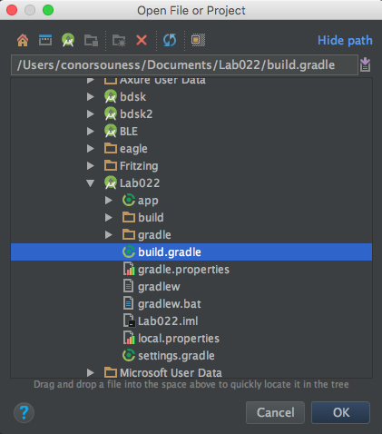

* 1. The build.gradle will auto generate all the project files needed.

## Running an app

75% of your time will be spent running apps to debug errors! Fun and soul-destroying stuff! We’ll start off by running the app!

The buttons are located above the editor.



**Build | Run|Run & Debug |Stop Application**

The hammer icon is to build a package. The Play button is used to run the app on your device. The bug icon with a play triangle is to run the app in debug mode. Big red square = stop running app.

* 1. If you have an Android phone please connect it to the computer now using the charging cabe.
  2. Run the app by clicking: Run.

The deployment target screen will pop up. This is where you choose where you want the app to run. You can select from phones that are connected to the computer via USB (connected devices) or running the app in an emulator on the computer (available virtual devices).

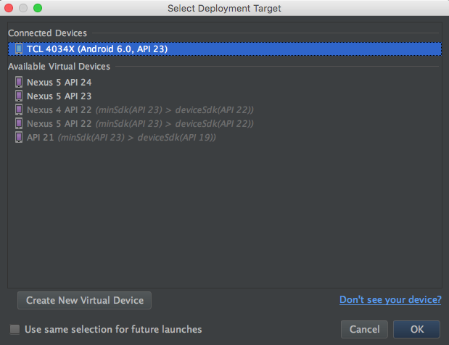

* 1. If you have a phone connected then it should appear as a connected device. select the connected device and then click OK.

If you do not have an android phone select a virtual device.

The app will build, install the apk and then launch on your device.

You will see the following on your phone or on the emulator:

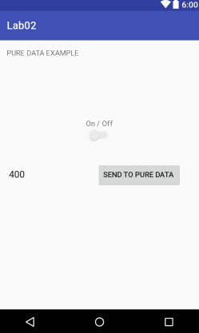

1.9. Tap the on/off switch on the app to turn on the synth.

There is a textfield to the left of the button that will send a desired frequency to pure data upon the click of the “Send to Pure Data” button.

Test different frequencies!

The sound you hear is generated by a PD patch that the app loads on startup. The GUI objects (the on/off switch, textfield and button) are used to pass data into the PD patch.

## Examining the template.

1.10 In Android Studio examine the project structure to the left. If it is hidden, there is a button on the left marked “Project”. Click this to reveal the project structure.

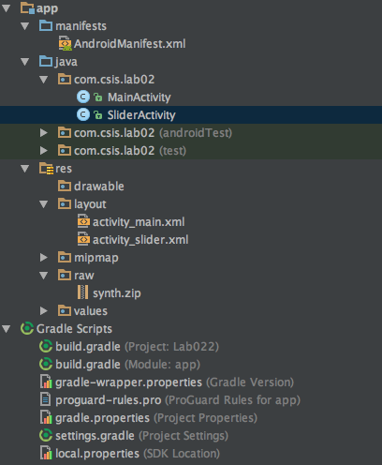

As you can see there are two main sections; “app” and “gradle scripts”. Gradle is what is used to build the project. App contains all the files needed for, well, the app.

App has three folders in this project. Manifest is used to dictate activity properties and permissions used by the app. Java contains the code that defines the behaviour of your app. Res contains all resources used by the app!

Resources include layouts, the visual screens in the app. These layouts are in a markup language called XML, similar to, but not the same as, HTML.

At project creation you can specify the launcher screen.

# Part 2: Pure Data

Lets look at how a pd patch is integrated into an android app in more detail. Following this we will practice editing the pd patch and updating our app. The aim here is that after this lab you will be able to create your won pd patches and run them on an android device.

**Where in the Project is the PD Patch?**

2.1. Locate the “res” section in the project pane. Then locate the folder named “raw”.

**This is the folder that holds the pd patch that the app runs.**

**The patch must be stored as a zip file. This is a limitation of the way pd is implemented in Android. We cant just drop in our patch.pd file. Instead it must be zipped first and the resulting .zip file added to the project.**

When the app runs on the phone it unzips the zip file and loads the patch.

2.2. The template has a zipped up patch already in place. It is called synth.zip.



2.3. You can locate this folder on the mac by right-clicking synth-zip in android studio and selecting “Reveal in Finder”. This makes copying and pasting easier! Open the folder that contains synth.zip in finder now.

2.4. In Finder, unzip the synth.zip file, by double clicking it. When it unzips you should now see a file named synth.pd. This is the pd patch that our app runs.



In finder Double click synth.pd to open it in PD (or in PD select file, open and navigate to the folder and open it). It should like the below.

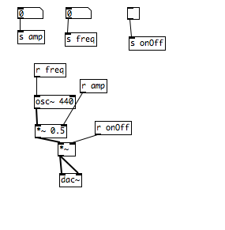

### A small aside: Send and Receive in PD

Note the [s ] and [r ] objects. S is short for send and r is short for receive. In pd we can use a [send ] and [receive ] pair instad of a patch chord. Look at the next figure. Any messages sent into [s cat] will arrive at the outlet of [r cat].

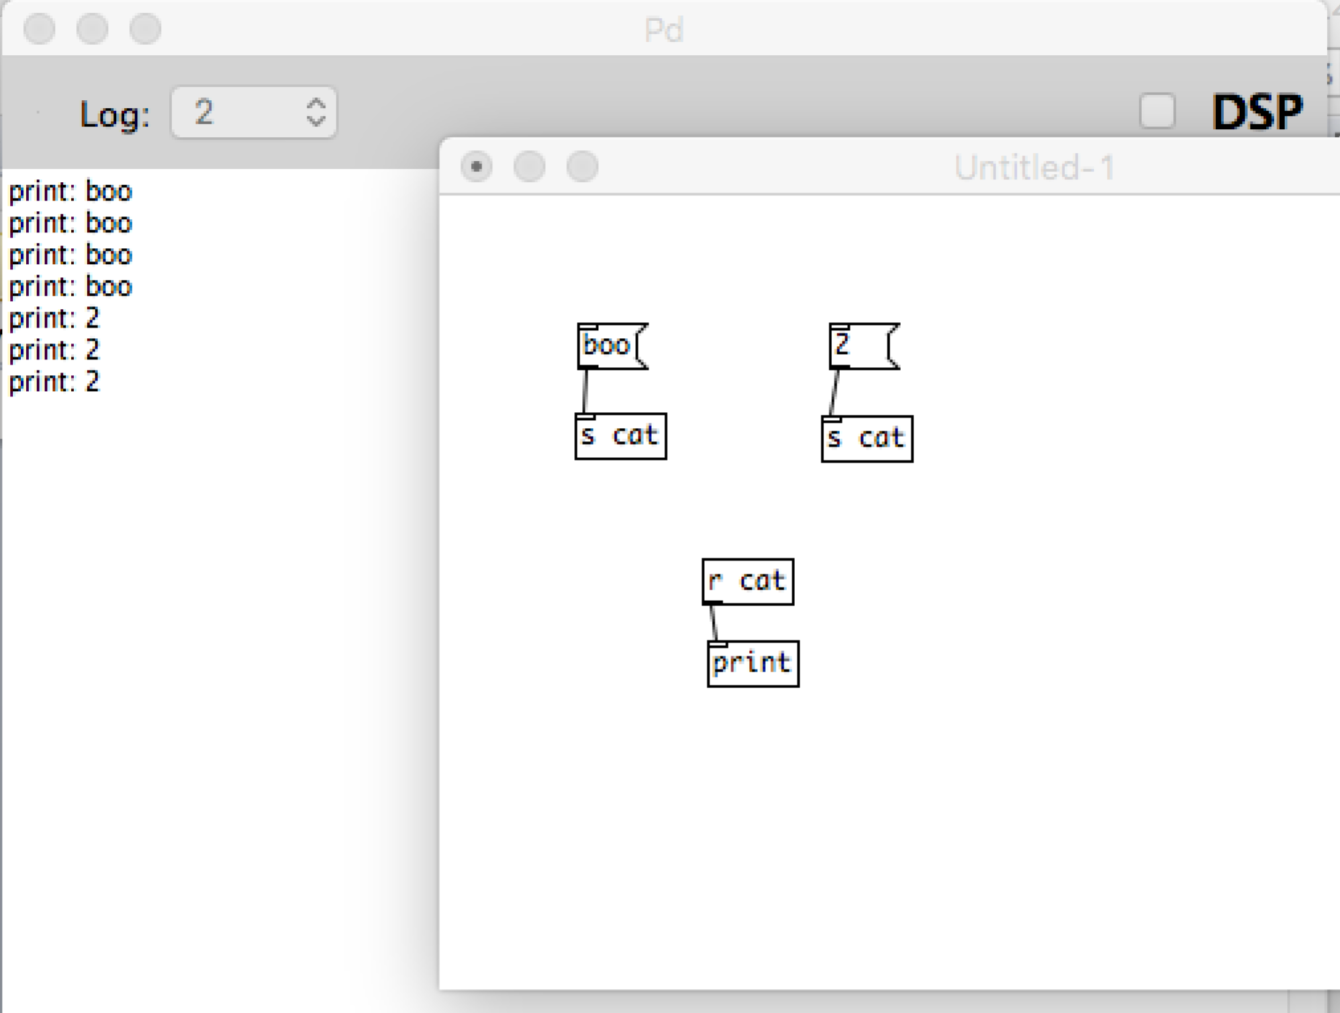

If this patch were loaded into an android app we could send data into it by addressing the receive objects. Another way to say this is that the pd patch receives data from the android app that it is loaded in via receive objects.

Lets look at out synth.pd patch again. Note the [r freq] object. The GUI of the app can send data to this receive object. This data will emerge from the [receive ] objects outlet.

What other [r ] objects are there in synth.pd? Which GUI object on the app sends data to [r amp] ? Which GUI object on the app sends data to [r onOff] ?

### Lets Edit the synth.pd patch and then test it in our app

2.5. Change the default frequency of the oscillator to 100Hz.

2.6. Save the patch.

2.7. In Finder select the existing synth.zip file and delete it. (it contains the old unedited copy of synth.pd).

2.8. Now create a new synth.zip file by right clicking on the synth.pd file, and choosing “Compress synth.pd”.

This will create a zip file called “synth.pd.zip”, we want to name it “synth.zip” as this is what the android app expects to find.

2.9. Click once on synth.pd.zip and when the text field appears, rename it to “synth.zip”.

2.10. Delete synth.pd

2.11. Go back to Android Studio.

2.12. Run the app. The default tone that we hear when the on/off switch is clicked on should now be 100hz. Is it?

### Part 2b: Extending our PD Patch and App

Lets extend the app so that we can control two oscillators. We’ll need to edit the PD patch. We’ll also need to add some new GUI objects to our app to control the new parts of our patch.

Lets edit the PD patch first.

2b.1. Locate the raw folder in Android Studio.

2b.2. Right click and locate the synth.zip in finder.

2b.3. Unzip the archive.

2b.4. Delete the archive.

2b.5. Open the synth.pd file in pure data.

2b.6. Edit the patch with the following changes:

Create a new oscillator with a default frequency of 220Hz.

Create a new [*~ ] to control its amplitude.

Create a new receive object called [r amp2] and connect it to the multiplier

Connect the output of the [*~ ] to the existing [dac~]

Test your patch in pd using toggles.

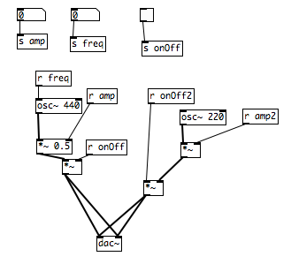

2b.7. Save the patch

2b.8. Close the patch

2b.9. Right click the synth patch, and click “Compress synth.pd”.

This will create a zip file called “synth.pd.zip”. Rename it “synth.zip”.

2b.11. Delete synth.pd

### Part 3a Examining and Creating GUIs

Now we want to create some new GUI objects in our app that will communicate with the new [receive ] objects in our PD patch.

3.1. Click on activity_main.xml in the project pane, it is located under res/layout.

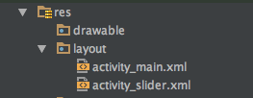

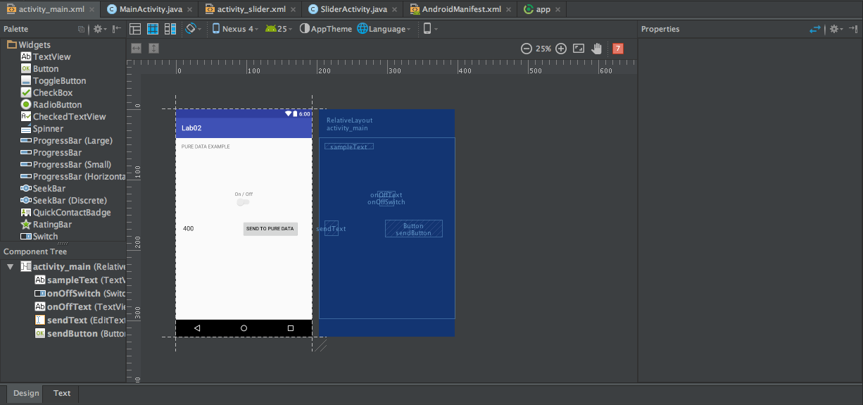

The design view is the default view. If the view is defaulted to text view, you can switch by pressing the highlighted button above.

This is the design tab. This is where you can drag and drop items to create your GUI. The widgets (indiidual GUI objects like buttons etc) are listed on the left, these can be dragged and dropped onto the screen.

Click on the “send to pd’ button widget that is already in place .

Its properties should now be shown in the properties tab to the right hand side..

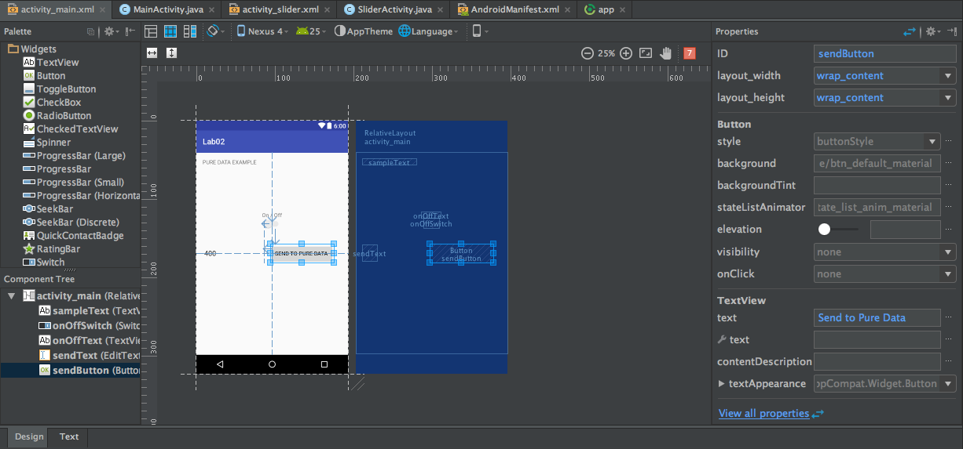

The most important property to note is ID. This ID is what we use to connect behaviours to the widget. We create behaviours or functionality in code and then attach this behaviour to the widget by specifying the ID that the behaviour should be connected to.

There are also items to set the text of the buttons, width and height of them too.

At the bottom left, click the Text tab to switch to xml editor view.

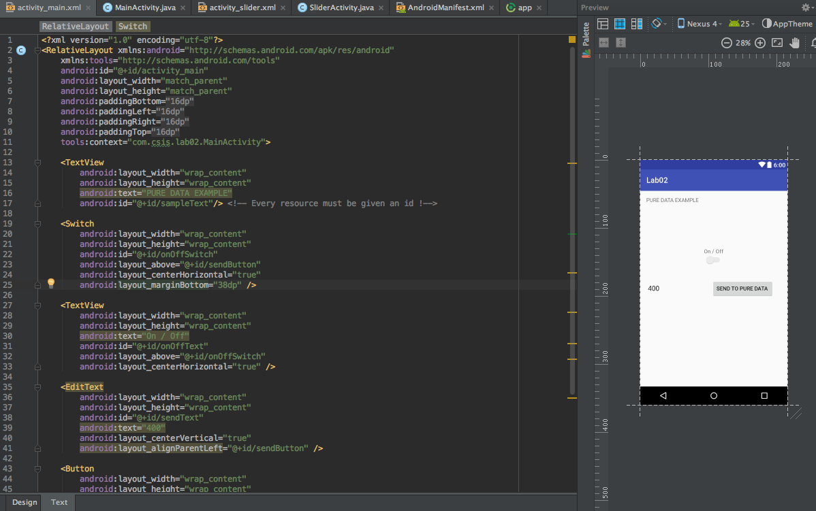

The text tab can be switched to by selecting the button highlighted above. This is the xml editor that generates what is seen in the design view. Changes in the design tab update the XML accordingly. When creating mobile applications, this is used by developers.

The format of each widget is:

<WIDGET_NAME

android:_____=” “

android:_____=” “

android:_____=” “/>

Android properties used will be layout properties, text and id.

All the widget code for buttons, switches, and textfields are seen here.

Pay attention to the comments in the code, I have highlighted the most pertinent information. Designing in the text tab allows precise creation of GUIs.

### Creating Functionality for Widgets

Part 1:

1. Double click activity_main.xml like before.

In the design tab, drag a button widget onto the screen under the “send to pure data” button.

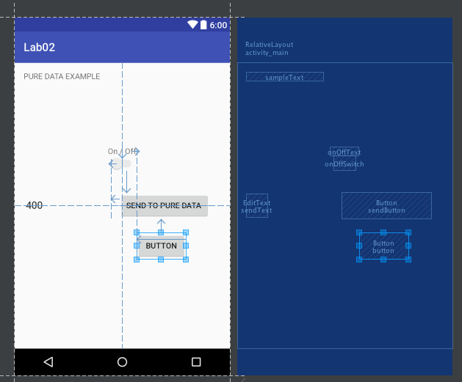

We need to add unique properties to the button for our code to access.

1. Go to the properties tab.

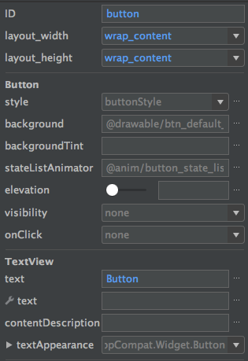

1. Rename the button ID to popUp.
2. Rename the button text to Pop Up

5. Now that we have placed the button and given it an id we will add functionality to it.

6. Double click the MainActivity.java file in the project pane. This is located under the java folder.

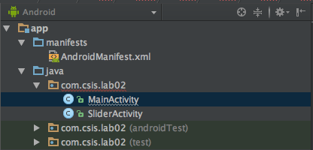

7. Go to line 36.



This is using the id for the “send to pure data” button typed in the properties section in the GUI design tab.

8.. Underneath this line add the following:

**Button pop = (Button) findViewById(R.id.popUp);**

This now points to the button you created with the id typed in the properties section of the Design Tab!

To add a listener that does something when the button is clicked, we will look at the code for the “send to pure data” button.

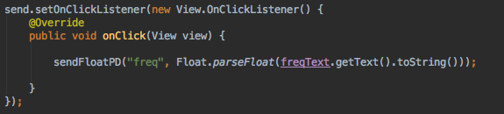

Here that button is assigned a listener that will activate on a click (hence, onClick).

7. Create the listener for the button **popUp**.

We’ll copy the format of the “Send to Pure Data” button!

Type this at line 78.

pop.setOnClickListener(new View.OnClickListener() {

@Override

public void onClicker(View view) {

//HERE GOES FUNCTIONALITY

}

});

8. Where you just typed the comment //HERE GOES Functionality, we’re going to replace that line with a popUp! In Android these are called Toasts. Because toasts pop up.



Build and run app and test! Any errors raise your hand!

**Things to note:**

I have code here to send floats to puredata. This sendFloatPD method can be called. It needs the name of the receiveEvent in the patch and a float!

In the sendButton it goes:

sendFloatPD(“freq”, Float.parseFloat(freqText.getText().toString()));

sendFloat needs two Strings: receiveEvent name and string value of float to send.

So if you added a editText in the gui for amplitude called ampText, you could then send it to a receiveEvent called amp with:

sendFloatPD(“amp”, Float.parseFloat(ampText.getText().toString()));

**Part 2:**

1. As you may notice in the project pane, I have another xml and java file regarding a slider. These are called seekbars in Android.

2. Your task is to bring the slider into your activity_main.xml and have that send the frequency to pure data each time it updates the value!

Similar to before, the slider must be declared and initialised in onCreate()

Hint: Listeners go in onCreate();

Pure data receiver is called “freq” for frequency;

Part 2:

1. Second slider for amplitude (i.e. volume) , max value must be 1. This must update and send to “amp” pd receiver;

### Mandatory Homework:

**You’ll need to edit the pure data patch for more functionality , 6 including the amplitude and frequency ( get creative!). Use buttons, switches, sliders and text fields to make a more complicated synthesiser!**